**All** children placed with relatives are entered in the Enter/Exit screens once either the agency or the relative has custody.

**Completing the Enter Resource screen:**

* Enter the resource name in the name fields if name and correct spelling are known, or select the county in which the resource resides (see below).

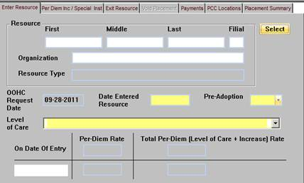

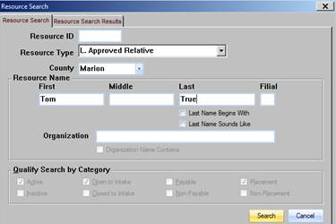

* If a name is entered, only that name will be returned in the search results, if found.
* If a county is selected all the resources in that county that are L. Relative Resources will be displayed in the search results.
* Highlight the name and click OK. This will populate the resource name on the Enter/Exit screens.
* If the relative is not located, complete the *Adding a Relative to the Resource Directory* form and email it to [CHFS TWIST Resource Dir](mailto:CHFS%20TWIST%20Resource%20Dir%20%3cCFC.TWISTResourceDir@ky.gov%3e) in central office. Staff who check this mailbox will enter this information.
* Once the relative is entered by central office, select the appropriate person in the Resource Directory by following the steps above.
* Next, under the **Resource Type** chose “Approved Relative” (regardless of who has custody) (see below)

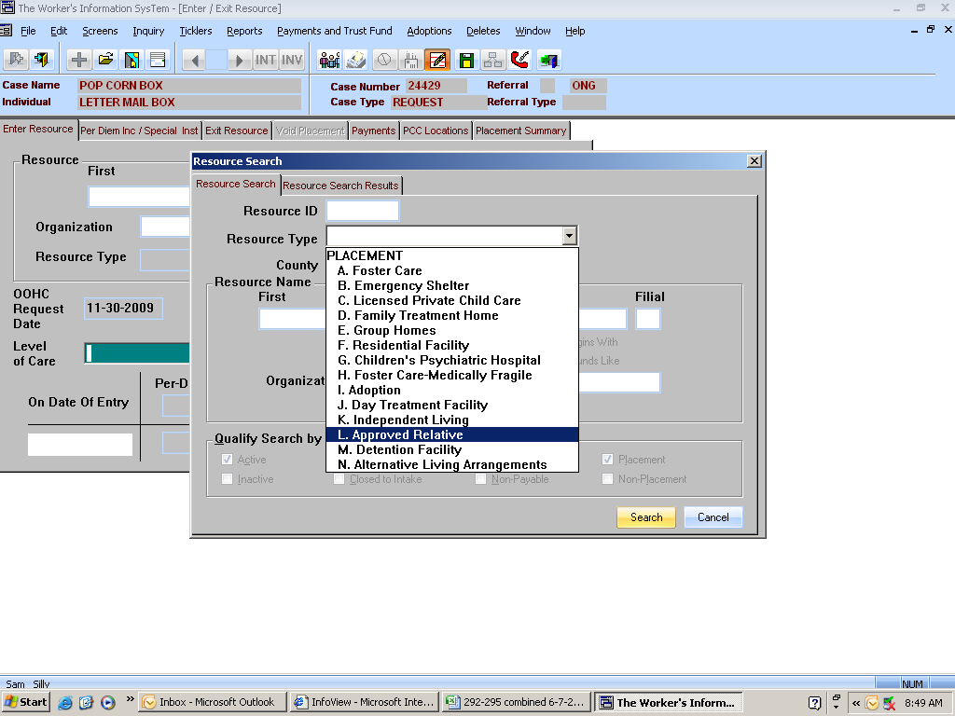

* In the **Level of Care** field, click on the drop down box that says Relative Placement ONLY for placements with a relative when the AGENCY has custody (see below).
* In the **Level of Care** field, click on the drop down box that says Kinship Care - Relative has custody ONLY for those placements where the RELATIVE has custody (see below). **[1]**

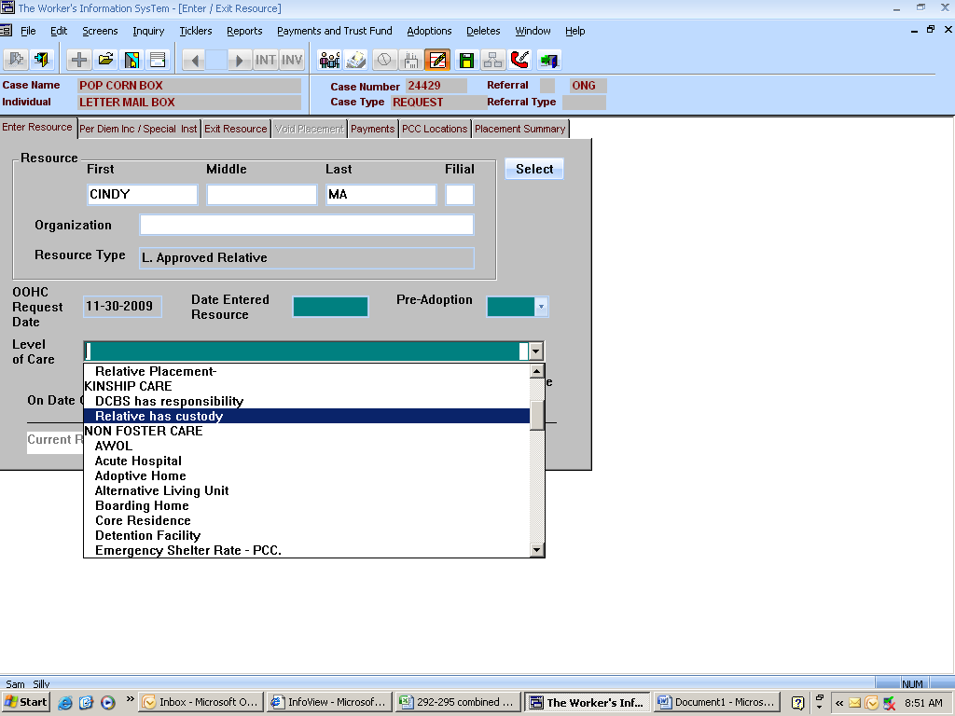

1. As not immediate changes to TWIST can be made, the use of the kinship care terminology will not be removed at this time.